**Task 13: Scan container images for vulnerabilities using Azure Security Center or a third-party tool. Share findings and mitigation steps**.

**Expected Output**: container-scan-report.txt, list of mitigations as a markdown file (mitigations.md).

* **container-scan-report.txt using TRIVY**



* **Container scan report from Azure Security Center**

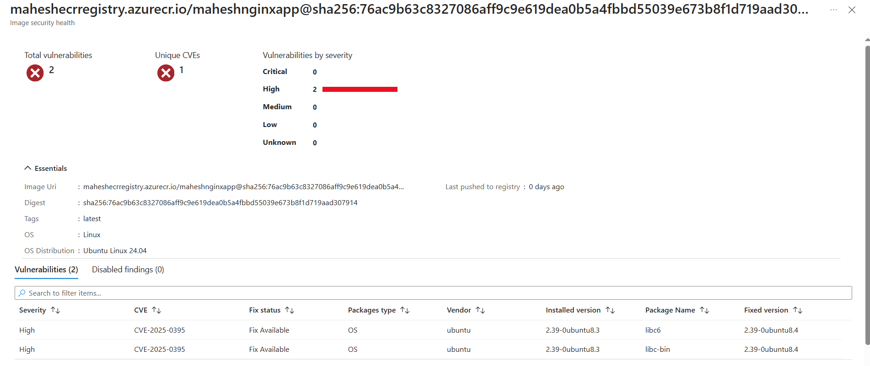

* **mitigations.md using TRIVY (HTML)**



* **mitigations.md using TRIVY (JSON)**



* **list of mitigations from Microsoft Defender for Cloud**

Manual remediation:

To resolve container image vulnerabilities:  
1. Navigate to the relevant resource under the 'Unhealthy' section and select the container image you are looking to remediate.  
2. Review the set of known vulnerabilities found by the scan by their severity.  
3. Select a vulnerability to view its details and explicit remediation instructions.  
4. Remediate the vulnerability using the provided instructions described in the 'Remediation' field.  
5. Upload the new remediated image to your registry. Review scan results for the new image to verify the remediated vulnerabilities no longer exist.  
6. Delete the old image with the vulnerabilities from your registry.

